**VIRTUAL FIELD DAY**

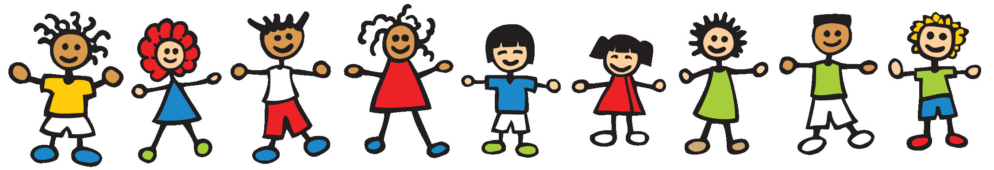

**Hi Kids and Families,**

**We know that this year has been challenging and we have missed some great activities! Mr Feiss and I have decided to offer some fun activities for you to participate it! There will be a video link at the bottom of this page which will have several videos explaining the activities. The activities were put together by another Elementary School Physical Education Team. Have fun with them! Make sure you put sunscreen on and get a drink when you need to!**

**LIST OF FUN ACTIVITIES**

1. **Spoon and Egg Race- Find a spoon and a real egg or plastic egg. Make a starting line and end line for your race. Make sure you get permission from an adult. Try to balance the egg on the spoon and run or walk from the starting line to the end line and back. Try to find someone to race against for added fun!**

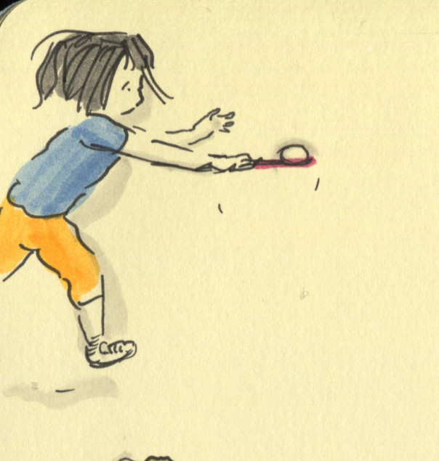

1. **Sponge Relay Race- Find an old sponge or wash cloth. Find two small buckets or plastic bowls. Put water in one of them. Set the buckets up in a straight line one at the starting line and one 20 steps away. On the word “GO” place your sponge or wash cloth in the bucket of water until it is filled with water. Run to the empty bucket and squeeze out the water from the sponge or washcloth into the bucket and run back. Try to get your whole family involved! Don’t get too wet!**

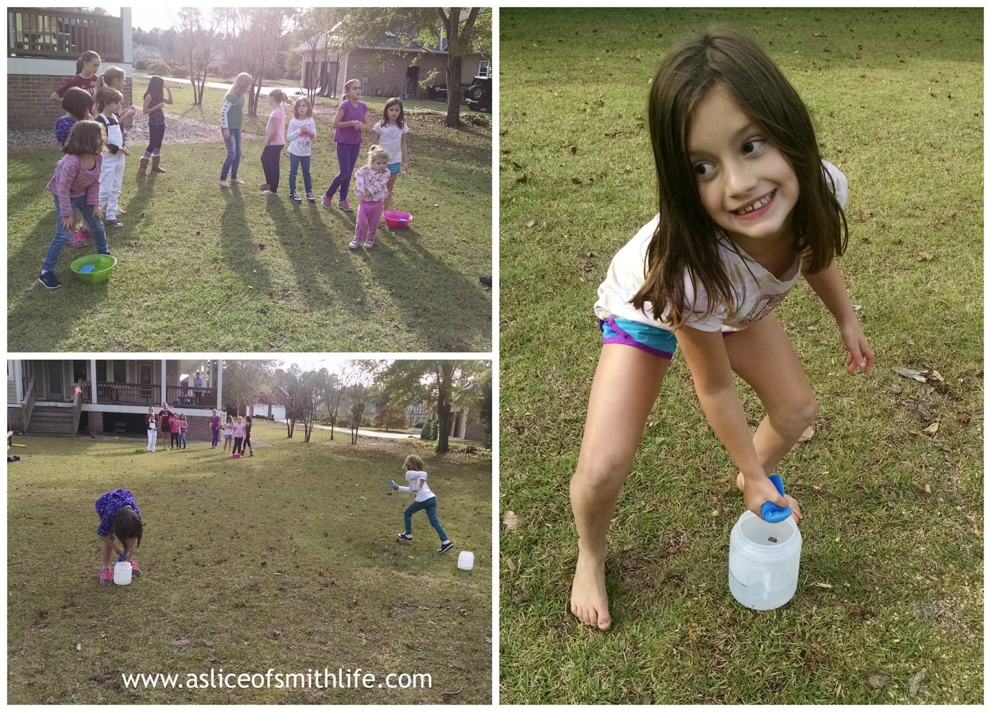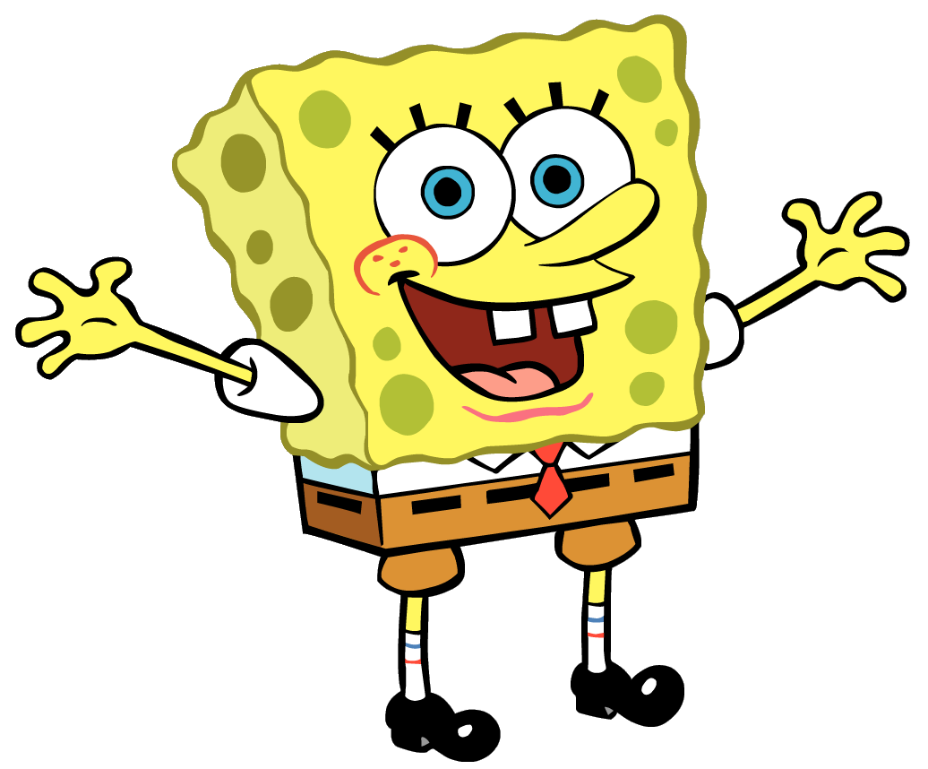

1. **Obstacle Course Race- Find 5 or 6 objects that you can safely jump over. Organize the objects in a straight line. Stand at one end and safely jump over each object and come back. If a family member has a stopwatch, they can time you. Try to do it faster the next time. Have fun and be safe!**

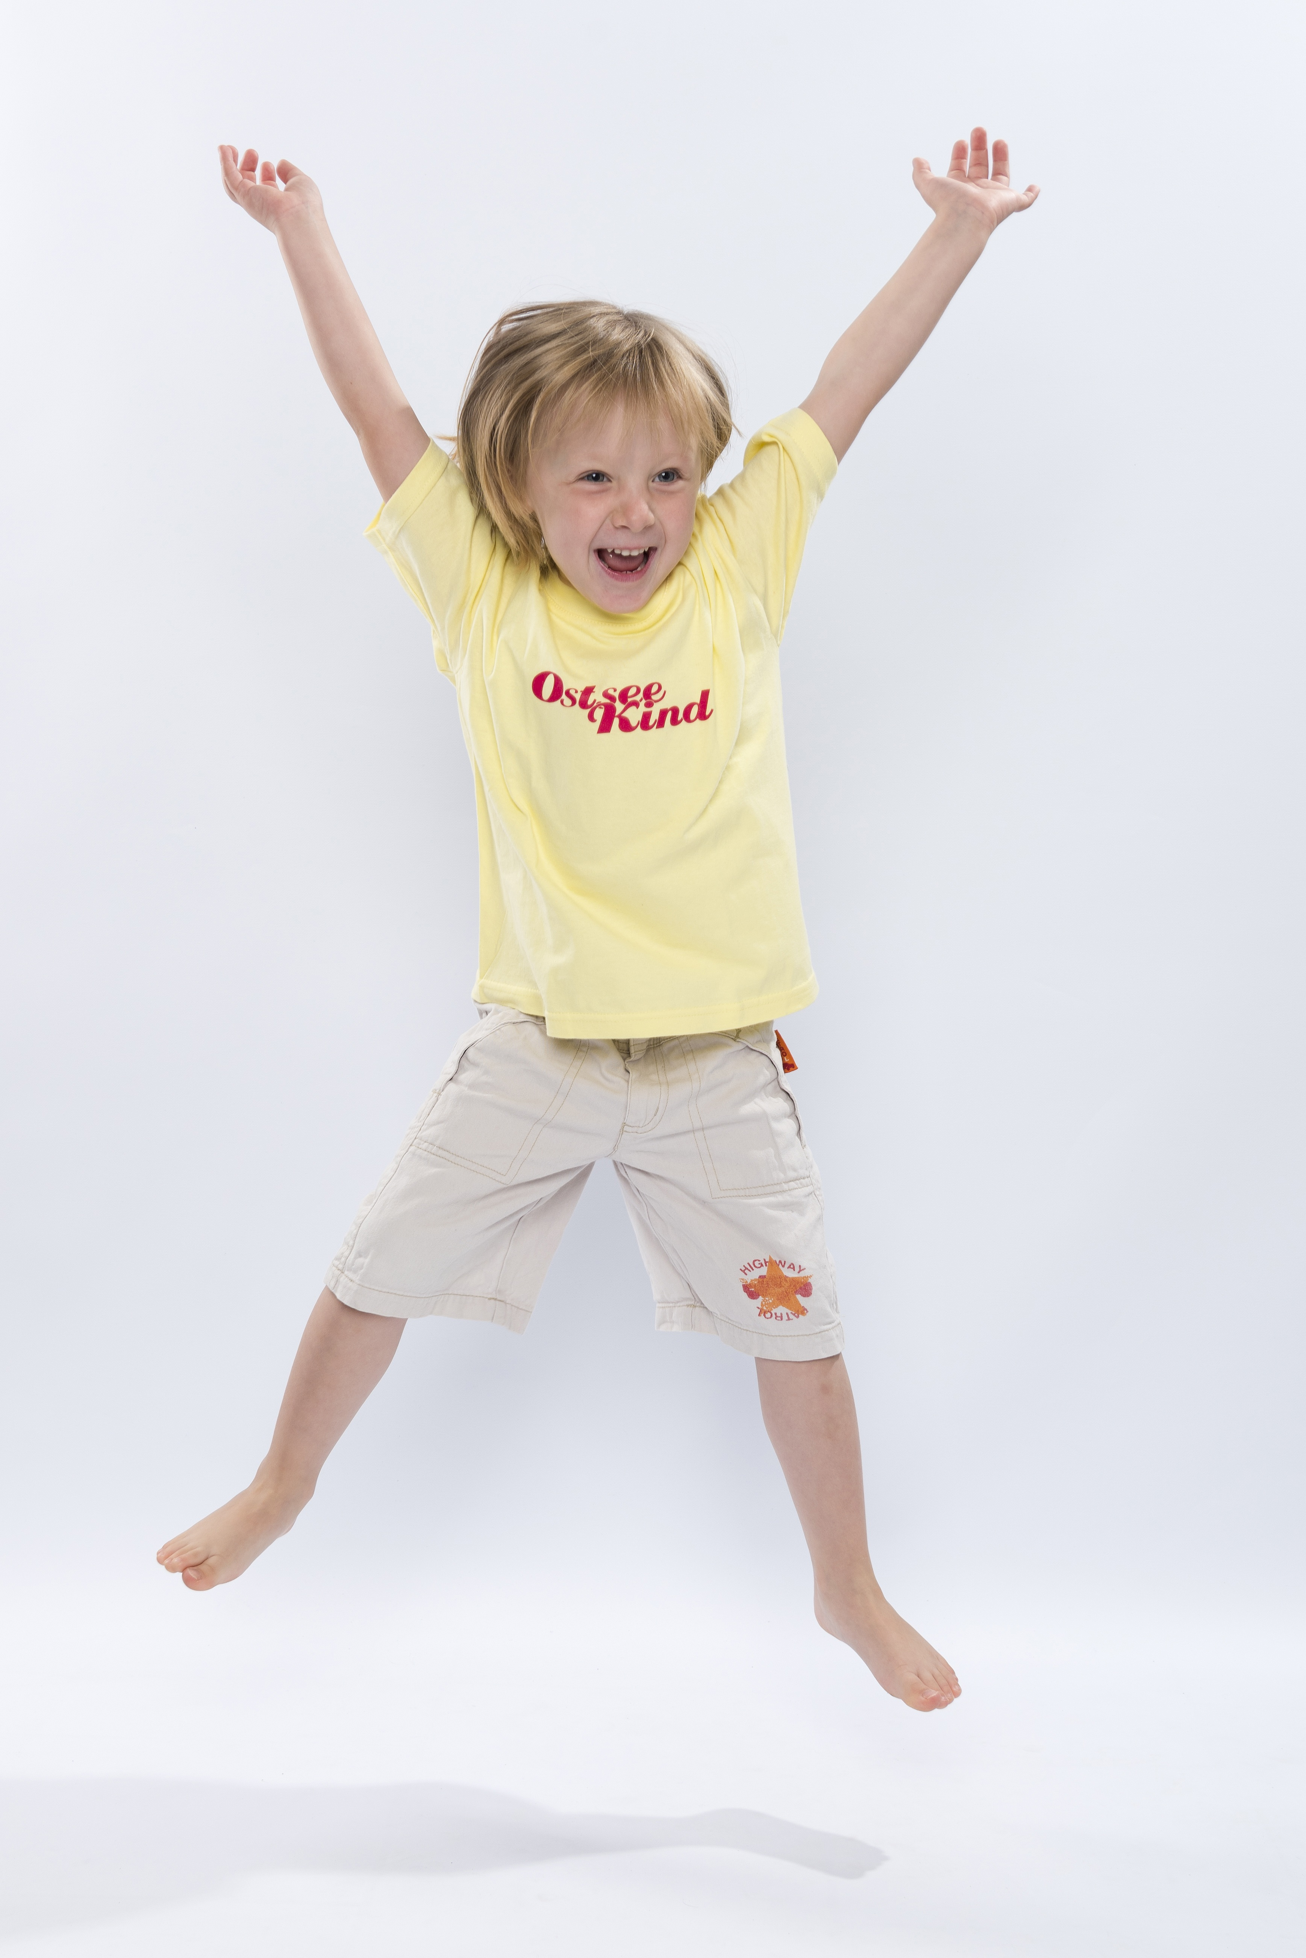

1. **The Bear Crawl- Find any soft ball either a playground ball or a nerf ball. Put the ball on the ground and bear crawl pushing the ball with your head or your hand from the start line to the finish line. If you can’t find a ball, just bear crawl down and back! Please be careful and have fun!**

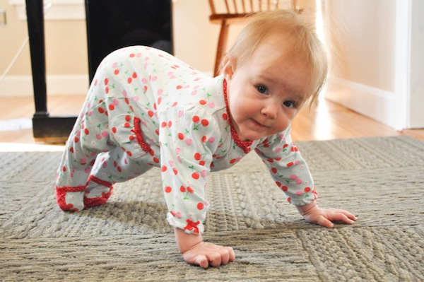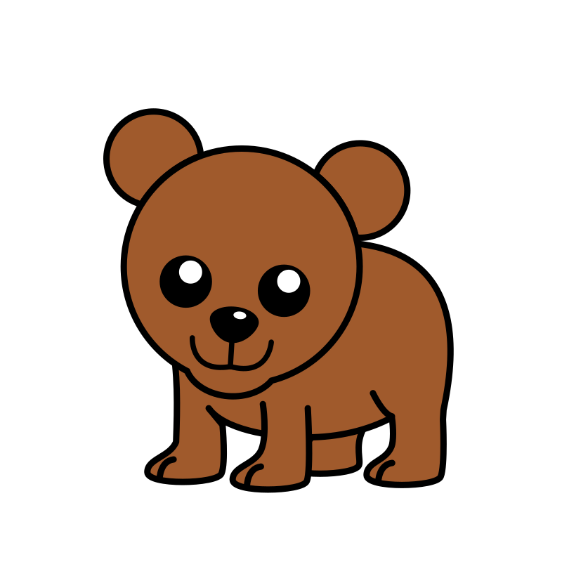

1. **Toss game- find a small soft ball or you can ball up a sock as a ball. Find another person to toss with. Stand across from your partner. Under hand toss and catch. Try to take a giant step backward and toss again. Keep taking a giant step backwards after each completed toss. See how far you can go! Have fun!** 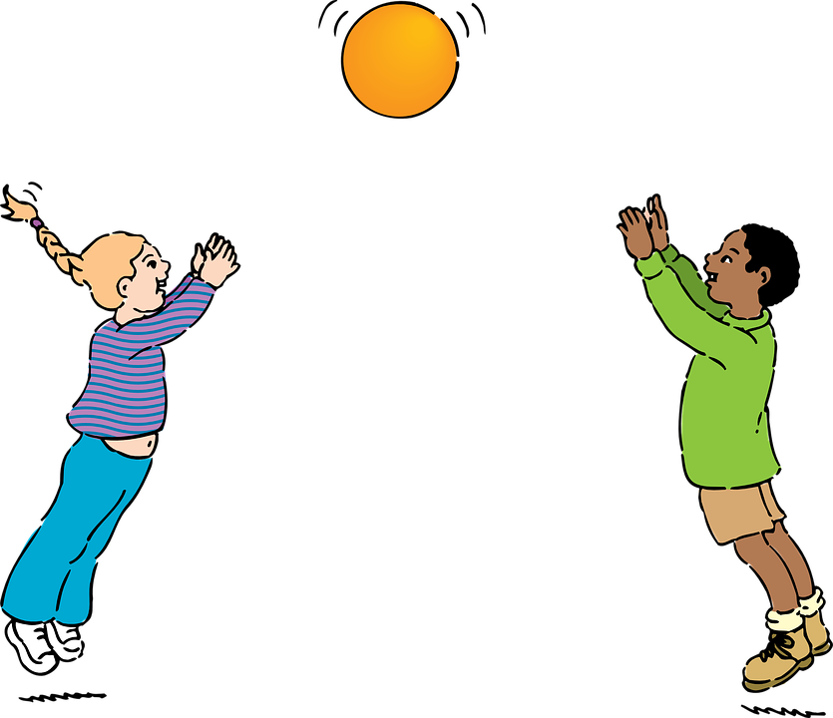
2. **Sidewalk Chalk Fun! - If you have sidewalk chalk and a place to draw outside you can do this event! Construct your own obstacle course using the chalk! You can draw a hopscotch board, arrows, circles, exercise words... Have fun and have your family try to complete your chalk obstacle course!**

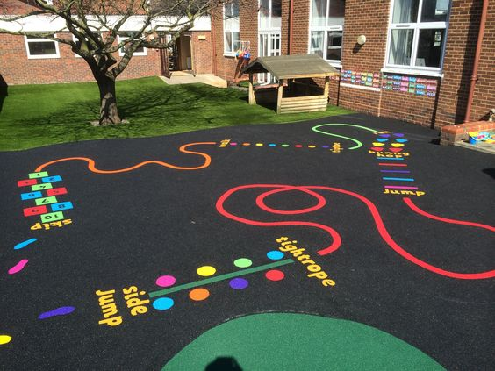

1. **Book Balancing Relay- Find any book! Create a start line and an end line. Balance the book on your head and walk down and back. Try to see if you can race someone else in your family. Add another book to your stack! Have Fun!**

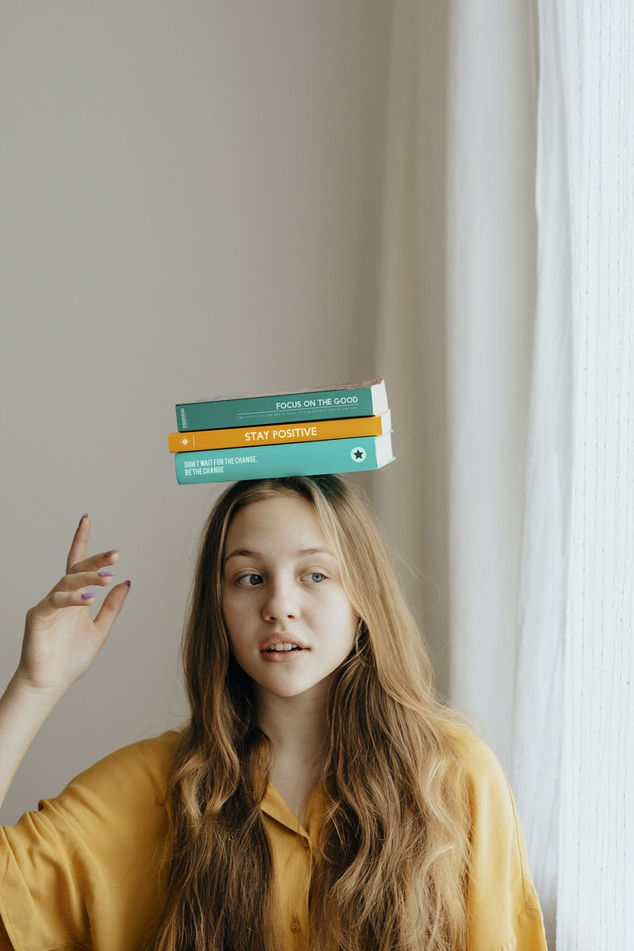

**\*\*\* Mr Feiss and I hope you had fun! There are several other events you can try on the video if you would like! If you would like to send any pictures of you participating in the events, please do so! We would like to post them on the school website!**

**Please send pictures to** [**MillerA@dvsd.org**](mailto:MillerA@dvsd.org) **or** [**FeissJ@dvsd.org**](mailto:FeissJ@dvsd.org)

**Below is the website with the videos of each event if you need to watch them!**

<https://www.youtube.com/watch?v=LmKoAEliZnM>

**Take Care and Have Fun!**

**Mrs Miller and Mr Feiss**

